Scenario: Schedule A Trip

|  |  |  |  |
| --- | --- | --- | --- |
|  | Comment | System Event | Response |
| 1 | Validate and Authorize user | Domain:authorize_user(“jane”, “word”) | Bool == true |
| 2 | Fetch the users role | Domain:get_role(“jane”, “word”) | “manager” |
| 3 | Create the referenced mana object based on factory |  | ScheduleATrip* st = factory::newScheduleatrip(); |
| 4 | Fetch the commands the user has access to | st.getCommands(“manager”); | Array of strings(“Schedule a Trip”, “Quit”) |
| 5 | Fetch a list of Cruises | st.cruisesInfo(); | An Array of strings with all the cruises that are in and not in service.  "1. Cuba, 10-May-2020, $5000", "N/A", "N/A" |
| 6 | Book a Room of the Cruise ship that the user selects. | st.executeCommand(“Schedule a Trip”, “2”, “2. Rio, 10-May-2020, $5000”, 2) | "You have changed the ship details" |
| 7 | End Session | Domian:signoff() | System exits |

Scenario 3: Schedule a Trip

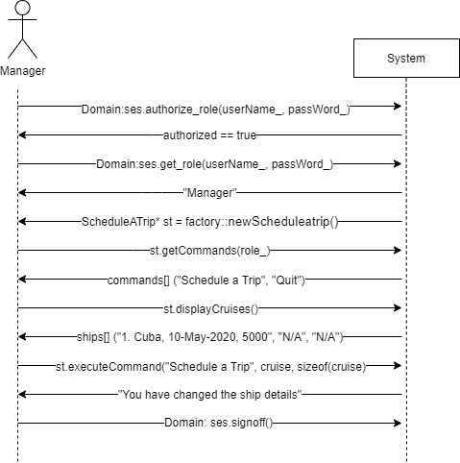

Brief Description:

A user will request to log into the system. The system responds with logging in the user, authenticating the user, generating object, and giving the user commands they can do. The user requests to do Schedule a Trip. The system responds with getting all the cruise ships in the system. The user requests to change one of the ships schedules. The system responds with a confirmation of the changed ship schedule. The user is then signed off the system.